**System Design - Architecture**

*(for further discussions)*

1. *Cloud AWS services* - [*Web Hosting*](https://aws.amazon.com/websites/?nc1=h_ls) via [*AWS Free Tier*](https://aws.amazon.com/free/?nc1=h_ls&all-free-tier.sort-by=item.additionalFields.SortRank&all-free-tier.sort-order=asc):
   1. Elastic Compute Cloud (Linux/UNIX or Windows server instance);

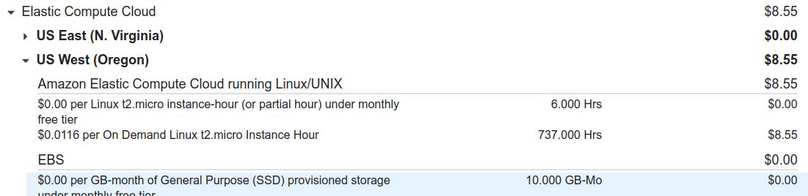

* 1. Amazon Registrar RenewDomain (Domain name registration - annual charge ~ 11$) - might be checked across others (cheaper) Domain registrators;
  2. Route 53 (Hosted Zones, DNS-Queries);

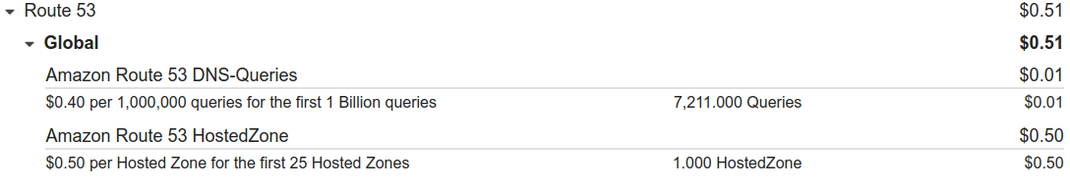

*NOTE: AWS Free Tier will provide CMS like* ***WordPress****, Drupal,* ***Joomla****, and more. AWS also supports and provides SDKs for popular platforms like Java, Ruby, PHP, Node.js, and .Net.*

1. Web Framework - [Django](https://www.djangoproject.com/) (proposed by @Nurzat).

This Python-based free and open-source web framework is intended to create highly scalable web applications or websites with a constantly growing audience (e.g. content-based or news sites). It follows the model-template-view (MTV) architectural pattern

[Django](https://steelkiwi.com/blog/why-django-best-web-framework-your-project/) perfectly works as is and provides users with a range of options to create Python-based web-applications including a user dashboard, various database supports (SQLite, PostgresSQL, MySQL), admin functions, and more.

Some useful [Django overview](https://steelkiwi.com/blog/why-django-best-web-framework-your-project/).

Famous websites using Django: [***Disqus***](https://disqus.com/)***,*** [***Instagram***](https://www.instagram.com/)***,*** [***Spotify***](https://www.spotify.com/)***,*** [***YouTube***](https://www.youtube.com/)***,*** [***The Washington Post***](https://www.washingtonpost.com/)***,*** [***BitBucket***](https://bitbucket.org/)***,*** [***DropBox***](https://www.dropbox.com/)***,*** [***Eventbrite***](https://www.eventbrite.com/)***,*** [***Mozilla***](https://www.mozilla.org/)***,*** [***Pinterest***](https://www.pinterest.com/)***,*** [***NASA Official Website***](https://www.nasa.gov/)***,*** [***National Geographic***](https://www.nationalgeographic.com/)***,*** [***Quora***](https://www.quora.com/)

1. CMS - [django CMS](https://www.django-cms.org/en/)

It is a free and open source content management system platform for publishing content on the World Wide Web and intranets. It is written in Django language framework, with Python

[Getting Started with django CMS](https://www.youtube.com/watch?v=NbsRVfLCE1U)

1. Deployment - [comparative analysis](https://djangostars.com/blog/top-django-compatible-hosting-services/)
   1. AWS Deploy [Django-based application](https://aws.amazon.com/getting-started/hands-on/deploy-python-application/)

[*Deploying a Django application to Elastic Beanstalk*](https://docs.aws.amazon.com/elasticbeanstalk/latest/dg/create-deploy-python-django.html) (*requires consultations or additional time for play before Matchthon*)

[Hosting Django Sites on Amazon Elastic Beanstalk](https://www.caktusgroup.com/blog/2017/03/23/hosting-django-sites-amazon-elastic-beanstalk/)

[Hosting a Django website on AWS EC2 — The Easy Way !](https://medium.com/@dikshitkathuria1803/hosting-a-django-website-on-aws-ec2-the-easy-way-3577ab4895d6)

[How to Deploy Django Applications on AWS EC2 Using Apache](https://medium.com/saarthi-ai/ec2apachedjango-838e3f6014ab) (*quite well prepared instruction!!!*)

[Deploying Django + Python 3 + PostgreSQL to AWS Elastic Beanstalk](https://realpython.com/deploying-a-django-app-and-postgresql-to-aws-elastic-beanstalk/) (*well prepared instruction*)

* 1. ...

1. Mat algorithm